Issue No. 1:
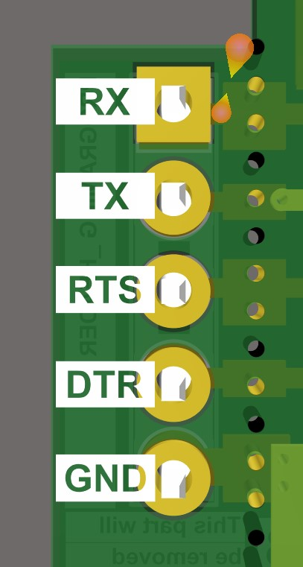
Reduce size of text as it is overlapping on copper are of pads of header. See attached image.

Issue No. 2:
Reduce the size of logo. See highlighted area in below image.
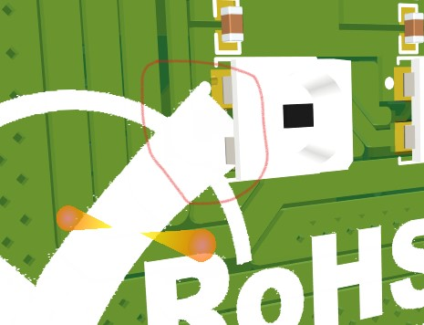

Issue No. 3:
Remove extra Mechanical layers (Mechanical 13 and Mechanical 15).

